Practice Questions

- It is required to have a pilot light come on when all of the following circuit requirements are met:
• All four circuit pressure switches must be closed.
• At least two out of three circuit limit switches must be closed.
• The reset switch must not be closed.
Using AND, OR, and NOT gates, design a logic circuit that will solve this hypothetical problem and also draw the ladder program.

2. For the logic gate circuit shown in Figure,
a. Determine the Boolean equation.
b. Draw an equivalent ladder logic program for the gate circuit.
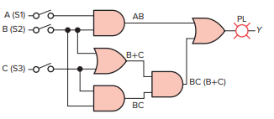
3. For the logic gate circuit shown in Figure,
a. Determine the Boolean equation.
b. Draw an equivalent ladder logic program for the gate circuit.
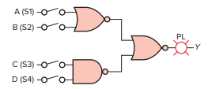
4. . Write the Boolean expression and draw the gate logic diagram and typical PLC ladder logic diagram for a control system wherein a fan is to run only when all of the following conditions are met:
• Input A is OFF
• Input B is ON or input C is ON, or both B and C are ON
• Inputs D and E are both ON
• One or more of inputs F, G, or H are ON

5. Figure shows the sketch of a drilling process that requires the drill press to turn on only if there is a part present and the operator has one hand on each of the start switches. This precaution will ensure that the operator’s hands are not in the way of the drill. The sequence of operation requires that switches 1 and 2 and the part sensor all be activated to make the drill motor operate. Develop the ladder logic program required for the process.
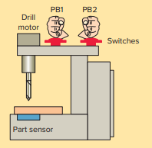

6. Figure shows the sketch of a continuous filling operation. This process requires that boxes moving on a conveyor be automatically positioned and filled. The sequence of operation for the continuous filling operation is as follows:
• Start the conveyor when the start button is momentarily pressed.
• Stop the conveyor when the stop button is momentarily pressed.
• Energize the run status light when the process is operating.
• Energize the standby status light when the process is stopped.
• Stop the conveyor when the right edge of the box is first sensed by the photo sensor.
• With the box in position and the conveyor stopped, open the solenoid valve and allow the box to fill. Filling should stop when the level sensor goes true.
• Energize the full light when the box is full. The full light should remain energized until the box is moved clear of the photo sensor.
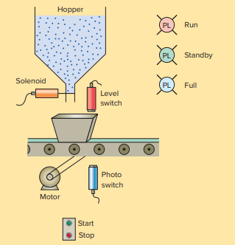
7. A pump is to be used to fill two storage tanks. The pump is manually started by the operator from a start/stop station. When the first tank is full, the control logic must be able to automatically stop flow to the first tank and direct flow to the second tank through the use of sensors and electric solenoid valves. When the second tank is full, the pump must shut down automatically. Indicator lamps are to be included to signal when each tank is full. a. Draw a sketch of the process. b. Prepare a typical PLC program for this control process.
8. Design a PLC program and prepare a typical I/O connection diagram and ladder logic program for the following motor control specifications: • A motor must be started and stopped from any one of three start/stop pushbutton stations. • Each start/stop station contains one NO start pushbutton and one NC stop pushbutton. • Motor OL contacts are to be hardwired.
9. Write a ladder logic program that will turn on a light, PL, 15 s after switch S1 has been turned on.
10. Write a program to implement the process illustrated in Figure. The sequence of operation is to be as follows:
• Normally open start and normally closed stop pushbuttons are used to start and stop the process.
• When the start button is pressed, solenoid A energizes to start filling the tank.
• As the tank fills, the empty level sensor switch closes.
• When the tank is full, the full level sensor switch closes
• Solenoid A is de-energized.
• The agitate motor starts automatically and runs for 3 min to mix the liquid.
• When the agitate motor stops, solenoid B is energized to empty the tank.
• When the tank is completely empty, the empty sensor switch opens to de-energize solenoid B.
• The start button is pressed to repeat the sequence.
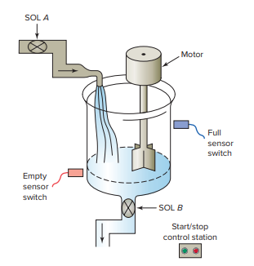
11. When the lights are turned off in a building, an exit door light is to remain on for an additional 2 min, and the parking lot lights are to remain on for an additional 3 min after the door light goes out. Write a program to implement this process.
12. Write a program to simulate the operation of a sequential taillight system. The light system consists of three separate lights on each side of the car. Each set of lights will be activated separately, by either the left or right turn signal switch. There is to be a 1-s delay between the activation of each light, and a 1-s period when all the lights are off. Ensure that when both switches are on, the system will not operate. Use the least number of timers possible. The sequence of operation should be as follows:
• The switch is operated. • Light 1 is illuminated. • Light 2 is illuminated 1 s later. • Light 3 is illuminated 1 s later. • Light 3 is illuminated for 1 s. • All lights are off for 1 s. • The system repeats while the switch is on.
13. Write a program that will increment a counter’s accumulated value 1 count every 60 s. A second counter’s accumulated value will increment 1 count every time the first counter’s accumulated value reaches 60. The first counter will reset when its accumulated value reaches 60, and the second counter will reset when its accumulated value reaches 12.

- Write a PLC program to operate a light according to the following sequence.
- A momentary push button is pressed to start the sequence
- The light is switched ON and remains ON for 2 s.
- The light is then switched off and remains off for 2 s.
- A counter is incremented by 1 after this sequence.
- The sequence then repeats for a total of 4 counts.
- After the fourth count, the sequence will stop and the counter will be reset to zero.

- Three conveyors feed a main conveyor. The count from each feeder conveyor is fed into an input register in the PLC. Construct a PLC program to obtain the total count of parts on the main conveyor. Use a timer to update the total every 15 seconds. Design, construct, and test PLC circuits for this process

- In certain process control application o/p is ON if the count is less than 34 or more than 41. Implement the same using PLC ladder diagram

- An indicating light is to go ON when a count reaches 23.The light is then go off when a count of 31 is reached. Design, construct, and test PLC circuits for this process

- In certain process control application when the count reaches 25, a paint spray is to run for 40 seconds. Design, construct, and test PLC circuits for this process.

- Write a program to implement the process illustrated in Figure below. An up-counter must be programmed as part of a batch-counting operation to sort parts automatically for quality control. The counter is installed to divert 1 part out of every 1000 for quality control or inspection purposes. The circuit operates as follows:
• A start/stop pushbutton station is used to turn the conveyor motor on and off.
• A proximity sensor counts the parts as they pass by on the conveyor.
• When a count of 1000 is reached, the counter's output activates the gate solenoid, diverting the part to the inspection line.
• The gate solenoid is energized for 2 s, which allows enough time for the part to continue to the quality control line.
• The gate returns to its normal position when the 2-s time period ends.
• The counter resets to 0 and continues to accumulate counts.
• A reset pushbutton is provided to reset the counter manually.

- Show a PLC ladder diagram to operate the fans and lights in a smart room
No.of Persons | Fans | Lights
1-5 | 1 | 1
6-10 | 3 | 3

